Theo van Doesburg (1883-1931)
Theo van Doesburg was a Dutch painter, designer and art theorist. As the founder and major polemicist of the avant-garde movement known as DE STIJL (The Style), he was instrumental in developing an abstract style based on primary colours and geometry. Tirelessly promoting De Stijl across Europe, van Doesburg played a crucial role in the development of Modernist art, architecture and design in the first half of the twentieth century.
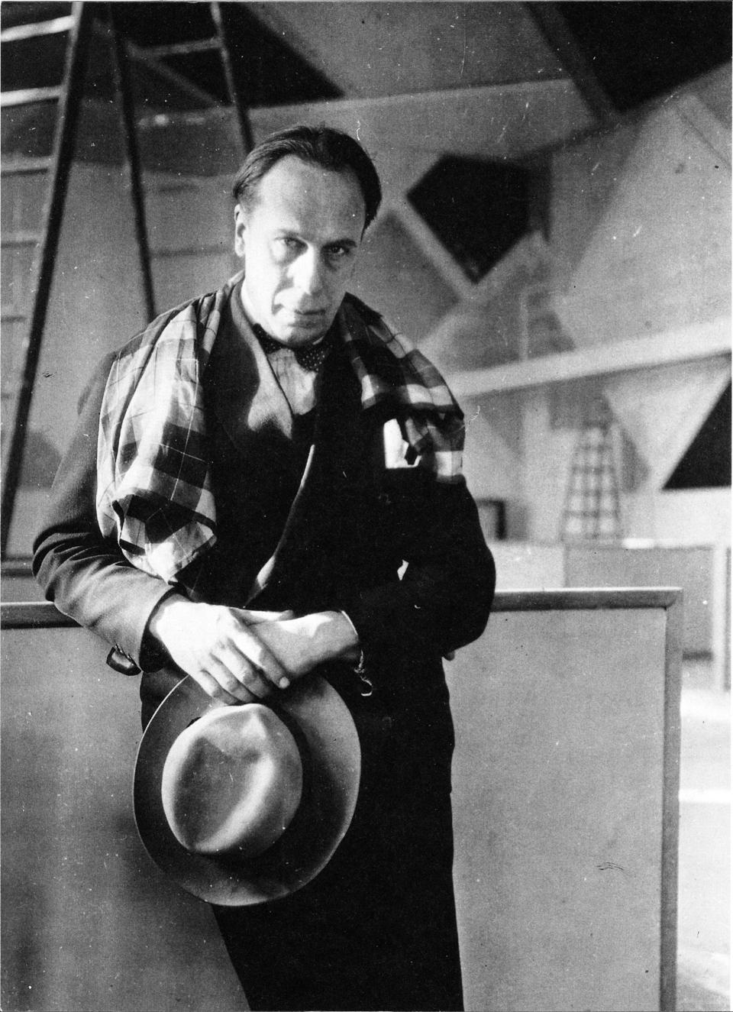
Theo van Doesburg in the Café de l’Aubette, Strasbourg, 1927
http://upload.wikimedia.org/wikipedia/commons/1/17/Theo_van_Doesburg_in_Aubette.jpg
Born Christian Emil Marie Küpper in Utrecht, van Doesburg was the son of the photographer Wilhelm Küpper. His pseudonym was developed from the name of his stepfather, Theodorus Doesburg, whom he regarded as his natural father. Van Doesburg became a painter around 1900. His early work was influenced by POST-IMPRESSIONISM and FAUVISM, but in 1915 he discovered the work of PIET MONDRIAN and underwent a profound transition. Mondrian had developed an austere visual style based on primary colours and orthogonal grids. This convinced van Doesburg to pursue spiritual harmony based on mathematical order.
Van Doesburg and Mondrian founded the avant-garde art magazine De Stijl in 1917. Inspired by the mystical ideas of theosophy, they sought an art of pure abstraction, which Mondrian later termed Neo-Plasticism. Van Doesburg had a magnetic personality and was adept at gaining support. The designer GERRIT RIETVELD was among the first to demonstrate how De Stijl could be extrapolated from the flat canvass to three-dimensional design objects and spaces.
Van Doesburg acted as the figurehead and international ambassador of De Stijl. He lectured intermittently at the BAUHAUS from 1922 to 1923 and his teaching encouraged Bauhaus designers to move away from their early Expressionistic and craft-based aesthetic towards pure geometric simplicity. After meeting the artist Kurt Schwitters, van Doesburg developed an interest in the provocative DADA movement. Using the alias I. K. Bonset (from the Dutch Ik ben sot – ‘I am a fool’), he exhibited as a Dada artist in Holland and published four issues of the Dada art review Mécano (1922–3).
In 1923 van Doesburg moved to Paris, which brought him into closer contact with Mondrian. Tensions between the two began to emerge, particularly concerning the use of diagonals. Van Doesburg insisted on the dynamic effect of diagonals as a necessary antithesis to the calculated harmony of Mondrian’s compositions. He named his new approach Elementarism and articulated it in a manifesto published in De Stijl in 1926.
Van Doesburg applied his talents to architecture and interior design. He created colour schemes, stained glass and tiled floors for houses designed by Jan Wils and J. J. P. OUD, reiterating the basic iconography of primary colours and pure geometric form. Between 1926 and 1928 he was engaged with the renovation of the Café de l’Aubette in Strasbourg, a collaboration with Hans Arp and Sophie Taeuber-Arp. Van Doesburg designed interiors consisting of rectangular panes of colour held in balance by the architectural framework. The completed design was greeted with little enthusiasm and was soon dismantled. It was, however, reconstructed in the 1990s and remains the most complete expression of Elementarist principles.
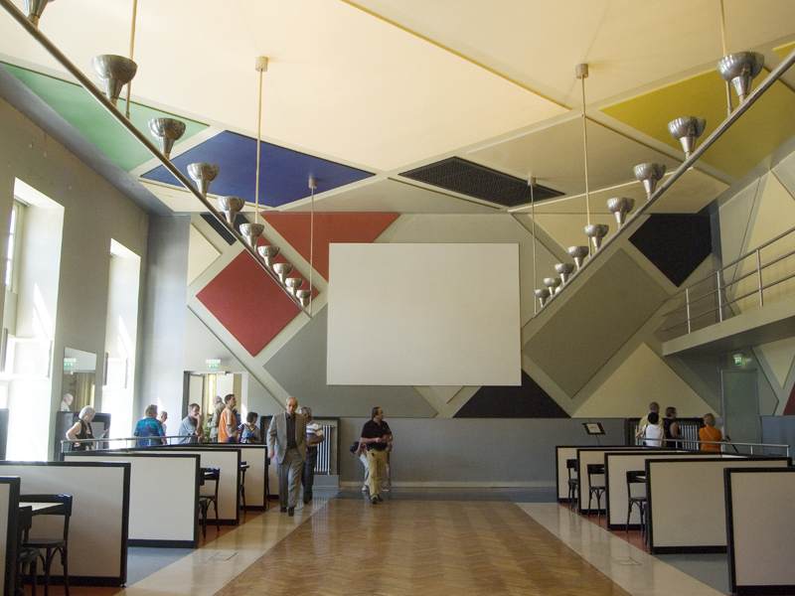
A reconstruction of the cinema-dance hall at the Café de l’Aubette in Strasbourg, designed by Theo van Doesburg, 1926-8.
http://upload.wikimedia.org/wikipedia/commons/e/e6/Cin%C3%A9-dancing_Strasbourg_-_Theo_van_Doesburg060611_006.jpg
Van Doesburg remained active in art groups such as Cercle et Carré and Art Concret. He designed a house and studio for his own occupation at Meudon outside Paris (1929-31). A meeting here in 1931 led to the formation of Abstraction-Création, a group that advocated pure abstraction. Van Doesburg moved to Davos in Switzerland due to ill health, but died of a heart attack on 7 March 1931.
List of works
De maskers af!, 1916.
De schilder De Winter en zijn werk, 1916.
De nieuwe beweging in de schilderkunst, 1917.
Drie voordrachten over de nieuwe beeldende kunst, 1919.
Klassiek-Barok-Modern, 1920.
Wat is Dada?, 1923.
Grundbegriffe der neuen gestaltenden Kunst, 1925.

References and further reading
Baljeu, J. (1974) Theo van Doesburg. London: Studio Vista. (A comprehensive monograph that analyses van Doesburg’s role as the editor of De Stijl and includes translations of his key writings).

Doesburg, T.V. (1983) Het andere gezicht van I.K. Bonset: literaire geschriften van Theo van Doesburg, I.K. Bonset en Aldo Camini, Amsterdam: Meulenhoff. (A collection of untranslated writings by van Doesburg, including those published under his pseudonyms I.K. Bonset and Aldo Camini).
Doig, A. (1986) Theo van Doesburg: painting into architecture, theory into practice. Cambridge: Cambridge University Press. (This text explores van Doesburg’s philosophy, architecture and painting).

Fabre, G.C., Wintgens Hötte, D. and White, M. (2009) Van Doesburg and the International Avant-Garde: constructing a new world. London: Tate. (This important text was the first to study van Doesburg’s influence throughout Europe and beyond, evaluating his role in the development of Modernist art, architecture and design).

Hedrick, H.L. (1979) Theo van Doesburg, Propagandist and Practitioner of the Avant-Garde, 1909-1923. Ann Arbor, Mich.: UMI Research Press. (An analysis of van Doesburg’s essays and poems, many of which were originally published in De Stijl).
Hoek, E., Blokhuis, M., Goovaerts, I. and Kamphuys, N. et al. (2000) Theo van Doesburg: Oeuvre Catalogus, Utrecht: Centraal Museum. (A Dutch-language catalogue of works by van Doesburg).
Leering, J. and Straaten, E. (1983) Theo van Doesburg, 1883-1931: een documentaire op basis van materiaal uit de schenking van Moorsel. Gravenhage: Staatsuitgeverij. (A Dutch-language text containing extracts from van Doesburg’s diary).

